Knowledge & Technology

Bangladesh Army University of Engineering & Technology (BAUET)
Qadirabad Cantonment, Natore-6431


Department of
COMPUTER SCIENCE AND ENGINEERING (CSE)

LAB FINAL

Course Code : CSE-2106
Course Tittle : Database Systems Laboratory

Submitted By Submitted To

Name : Zarif Ahnaf Dhrubo Md. Atikur Rahman
ID : 0812310205101023 Assistant Professor,
Batch : 17th Dept. of CSE, BAUET
Year : 2nd
Semester : 1st Momenul Haque
Section : A Lecturer,
Session : 2022-2023 Dept. of CSE, BAUET

1. Show all flights that are not using aircraft models "Boeing 737" or "Airbus A320".

Query: SELECT * FROM Flights Natural join Aircraft where Aircraft.model not in ("Boeing 737",'Airbus A320')
Output

2.Show all flights departing between '2024-10-25 06:00:00' and '2024-10-25 10:00:00'.

Query: SELECT * FROM Flights Where Flights.DepartureTime between "2024-10-25 06:00:00" and "2024-10-25 10:00:00"

Output

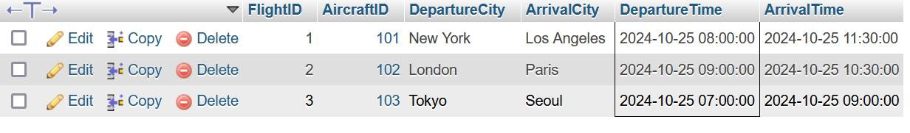
3. Develop a SQL query to find passengers who have bookings for flights where the aircraft status is 'Active'.

Query: Select Passengers.FirstName, Passengers.LastName from Passengers Natural JOIN bookings natural join flights natural join Aircraft where Aircraft.Status = "Active";

Output
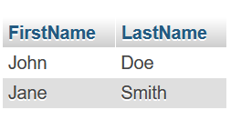

4. Construct a SQL query to combine the results of all active flights and all inactive flights into one
list.

Query: SELECT * FROM flights natural join Aircraft where Aircraft.status in ("Active","Inactive");
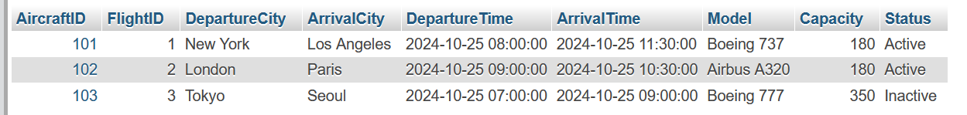
Output

5. Perform the following operations:
- Add a column FlightStatus (VARCHAR(20)) to the Flights table with the default
value 'Scheduled'.
- Delete all bookings where the SeatNumber is '15B

Query: ALTER TABLE Flights add FlightStatus varchar(20) default 'Scheduled';
DELETE from bookings where bookings.SeatNumber in ("15B");

Output
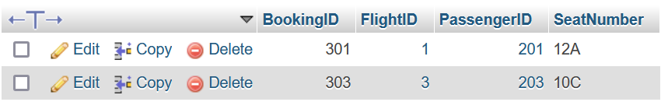
6. Develop a SQL query to retrieve the details (PassengerID, FirstName, LastName, and Email) of passengers who have booked at least one flight with an arrival city of "Los Angeles."

Query: SELECT Passengers.PassengerID, passengers.FirstName, passengers.LastName, passengers.Email from passengers natural join Flights where Flights.ArrivalCity = "Los Angeles";

Output
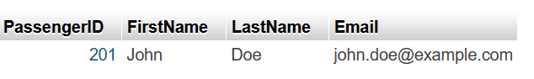
7.Develop a SQL query to list the details (AircraftID, Model, Capacity, and Status) of all aircraft
that have never been associated with any flight that has bookings.

Query: Select Aircraft.AircraftID, Aircraft.Model, Aircraft.Capacity, Aircraft.Status from Aircraft left join flights on flights.AircraftID = aircraft.AircraftID left join Bookings on bookings.FlightID = flights.FlightID where bookings.BookingID is null;

Query: SELECT Aircraft.AircraftID, Aircraft.Model, Aircraft.Capacity, Aircraft.Status FROM Aircraft WHERE Aircraft.AircraftID NOT IN (SELECT DISTINCT Flights.AircraftID FROM Flights JOIN Bookings ON Flights.FlightID = Bookings.FlightID);
Output
